Criminal Record System

1. Aya Sayed Samy (Section 11)
2. Fatma Hamdy Mohamed (Section 8)
3. Fatma Hossam Soliman (Section 8)
4. Gehad Wael Ibrahim (Section 8)
5. Mariam Mostafa Hanfy (Section 8)
6. Mariam Mostafa Mahmoud (Section 8)
7. Mariam Tarek Anwar (Section 8)

Supervised By

Ty : Mohamed Reda

Phase 1: **Requirements Phase**

* **Inputs & Processing**:

**“Collected by all team members”**

The data stored in a criminal record include: [National ID, Full Name, Gender, Date of birth, Birthplace, Age, Address, Nationality, Martial Status, Occupation,

Physical description (Height, Weight, Body Build, Blood Type...etc.)

Criminal History (crime id, criminal id, charge, disposition or sentence)].

When a crime is recorded, it's not necessary that it has been cleared up (solved) by the police. It may lack some information or the criminal hasn't been found, yet, such kind of crimes are not related to us.

Crimes that have been cleared up by the police are called "detected crimes". For any crime to be counted as 'detected', sufficient evidence must be available, and all of the following conditions must be met:

- a notifiable offence has been committed and recorded.

- a suspect has been identified and has been made aware that they will be recorded as being responsible for committing that crime and what the full implications of this are.

In our criminal record system, we only record detected crimes, since these are the types of crimes that must include an offender(criminal).

Note that there are two types of detections:

Sanction detections: which include offences that are cleared up through a formal sanction to the offender.

Non-sanction detections: include offences that were cleared up but no further action was taken against the offender.

When a criminal offence is recorded, it includes the following attributes: (a unique id, time, place, type, evidence).

It may also have additional attributes, like: victim(s), witness(es).

The main types of criminal offences are: (Drug offences, violence, burglary and robbery, theft, fraud and forgery, criminal damage(vandalism), murder,

anti-social behavior, and driving offences).

If there are victims for the crime, there are some information stored about them including (National ID, Name, Age, Gender, Country of residence, Martial Status, Occupation).

* **USED TOOLS 🡪 Microsoft Word**
* **USED METHODS 🡪 INTERNET & BRAINSTIORMING**
* **OUTPUT:**

A Criminal record system is used to show a person's criminal history. Criminal records may be needed by employers and others to see a person's trustworthiness. They may also be relevant for international travel, and for the charging and sentencing of persons who commit additional criminal offences.

The people who have access to the system database are the police forces and government personnel. The police force or the person who can access the system is called an **Admin**. To access the system, the admin needs to log in by entering their (ID, name, password). After logging in, the admin will have to choose one of two options:

1. Record information, as in first scenario.
2. Get information, as in second scenario.

**First Scenario:**

When a crime **(**offence**)** is detected, a police force (who is an admin on the system) logs into the system and records the **Offence** details, like: (ID, Time, Place, Type, Evidence).

They also record the **Criminal** data, which include:

[National ID, Full Name, Gender, Date of birth, Birthplace, Age, Address, Nationality, Martial Status, Occupation, and also their **Physical description** (Height, Weight, Body Build, Blood Type)].

And, if there was a victim in the crime scene, data about the **Victim** is recorded, such as: (National ID, Offence ID, Name, Age, Gender, Country of residence, Martial Status, Occupation).

**Second Scenario:**

When a person’s criminal history is needed for some reason (like stated above), an admin has to log into the system, then they enter the person’s full name and national ID. If the person was recorded on the system, their whole criminal history is showed, all criminal offences that person has committed and the punishment they got can be viewed in detail by the admin (the police forces or government personnel).

Phase 2: **Analysis Phase**

* **INPUT:**

A Criminal record system is used to store and show a person's criminal history.

People who can access the system are **Admin**s. We keep track of each admin’s ID, name, password. And, each time an admin wants to log into the system, they have to provide these three fields in order to record or access information on the system.

1. When an admin records a crime (**offence**), they store its (time, place, type, evidence), and it’s given a unique id.

They also store the **criminal** data 🡪 **[**National ID, Full Name, Gender, Date of birth, Birthplace, Age, Address, Nationality, Martial Status, Occupation, **physical description** (Height, Weight, Body Build, Blood Type)**]**. And, if there’s a **victim**, their data 🡪 (National ID, Name, Age, Gender, Country of residence, Martial Status, Occupation) will be provided as well.

1. In a person’s **criminal history**, we store data like (offence id, criminal id, charge, sentence), in order to link the criminal with the crime(s) they have committed. And, any admin can see the person’s full criminal history by providing that person’s name and id.

* **USED TOOLS 🡪 Microsoft Word & EDraw Max Tool**
* **EXTRACTION PROCESS:**

|  |  |
| --- | --- |
| **Entities** | |
| **Regular Entities** | **Weak Entities** |
| * Criminal * Criminal History * Offence * Admin | * Victim |

|  |  |  |
| --- | --- | --- |
| **Attributes** | | |
| **Enitity Name** | **Attribute Name** | **Attribute Type** |
| **Admin** | Admin ID | PK |
| Admin Name | Simple/Single |
| Password | Simple/Single |
| **Criminal** | Criminal ID | PK |
| Full Name | Composite/Single |
| Gender | Simple/Single |
| Date of birth | Composite/Single |
| Birthplace | Simple/Single |
| Age | Derviated |
| Address | Composite/Multivalued |
| Nationality | Simple/Multivalued |
| Marital Status | Simple/Single |
| Occupation | Simple/Single |
| Physical Descripton | Composite |
| **Criminal**  **History** | Offence ID | PK |
| Criminal ID | PK |
| Charge | Simple |
| Sentence | Simple |
| **Offence** | Offence ID | PK |
| Type | Simple/Single |
| Place | Simple/Single |
| Time | Simple/Single |
| Evidence | Simple/Multivalued |
| **Victim** | Victim ID | PK |
| Offence ID | PK |
| Name | Compsite/Single |
| Gender | Simple/Single |
| Age | Simple/Single |
| Country | Simple/Single |
| Occupation | Simple/Single |

|  |  |  |  |  |  |  |
| --- | --- | --- | --- | --- | --- | --- |
| **Relationship** | | | | | | |
| **Number of Entities** | | | | | **Name of relationship** | **Degree of relationship** |
| **Name E1** | **Name E2** | **Name E3** | **Name E4** | |
| Admin | Criminial | Offence | Victim | Records | | Quaternary R |
| Admin | Criminal History |  |  | Reads | | Binary R |
| Criminal | Criminal History |  |  | Has | | Binary R |
| Criminal History | Offence |  |  | Added | | Binary R |
| Offence | Victim |  |  | Acted upon | | Binary R |

|  |  |  |  |  |  |
| --- | --- | --- | --- | --- | --- |
| **Cardinality** | | | | | |
| **Number of Entities** | | | | **Name of relationship** | **Cardinality** |
| **Name E1** | **Name E2** | **Name E3** | **Name E4** |
| Admin | Criminial | Offence | Victim | Records | M : M : M : M |
| Admin | Criminal History |  |  | Reads | M : M |
| Criminal | Criminal History |  |  | Has | 1 : M |
| Criminal History | Offence |  |  | Added | 1 : M |
| Offence | Victim |  |  | Acted upon | 1 : M |

|  |  |  |  |  |  |
| --- | --- | --- | --- | --- | --- |
| **Participations** | | | | | |
| **Number of Entities** | | | | **Name of relationship** | **Type of participation** |
| **Name E1** | **Name E2** | **Name E3** | **Name E4** |
| Admin | Criminial | Offence | Victim | Records | P : T : T : T |
| Admin | Criminal History |  |  | Reads | Partial : Partial |
| Criminal | Criminal History |  |  | Has | Total : Total |
| Criminal History | Offence |  |  | Added | Total : Total |
| Offence | Victim |  |  | Acted upon | Partial : Total |

* **OUTPUT:**

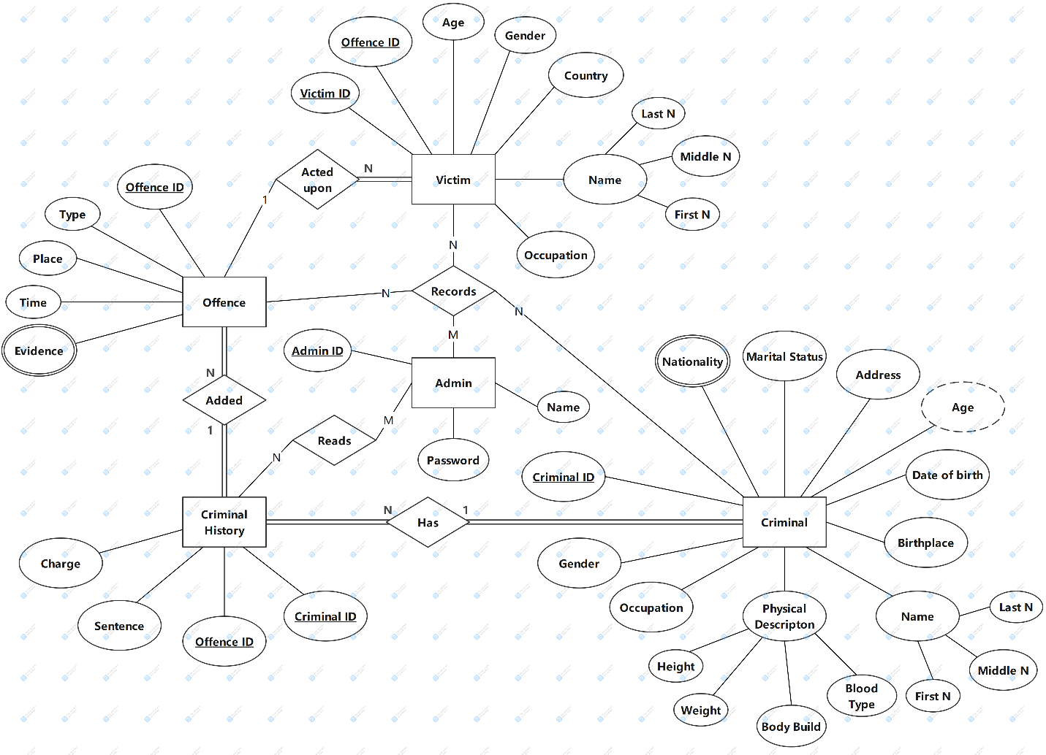

Phase 3 : Design Data

**-INPUT:**



**-OUTPUT:**

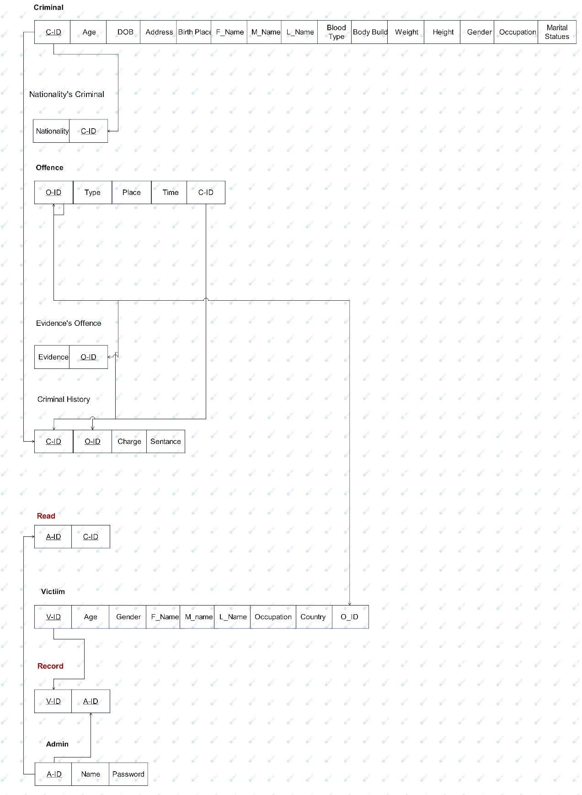

Phase 3:Normalaization

**-INPUT:**

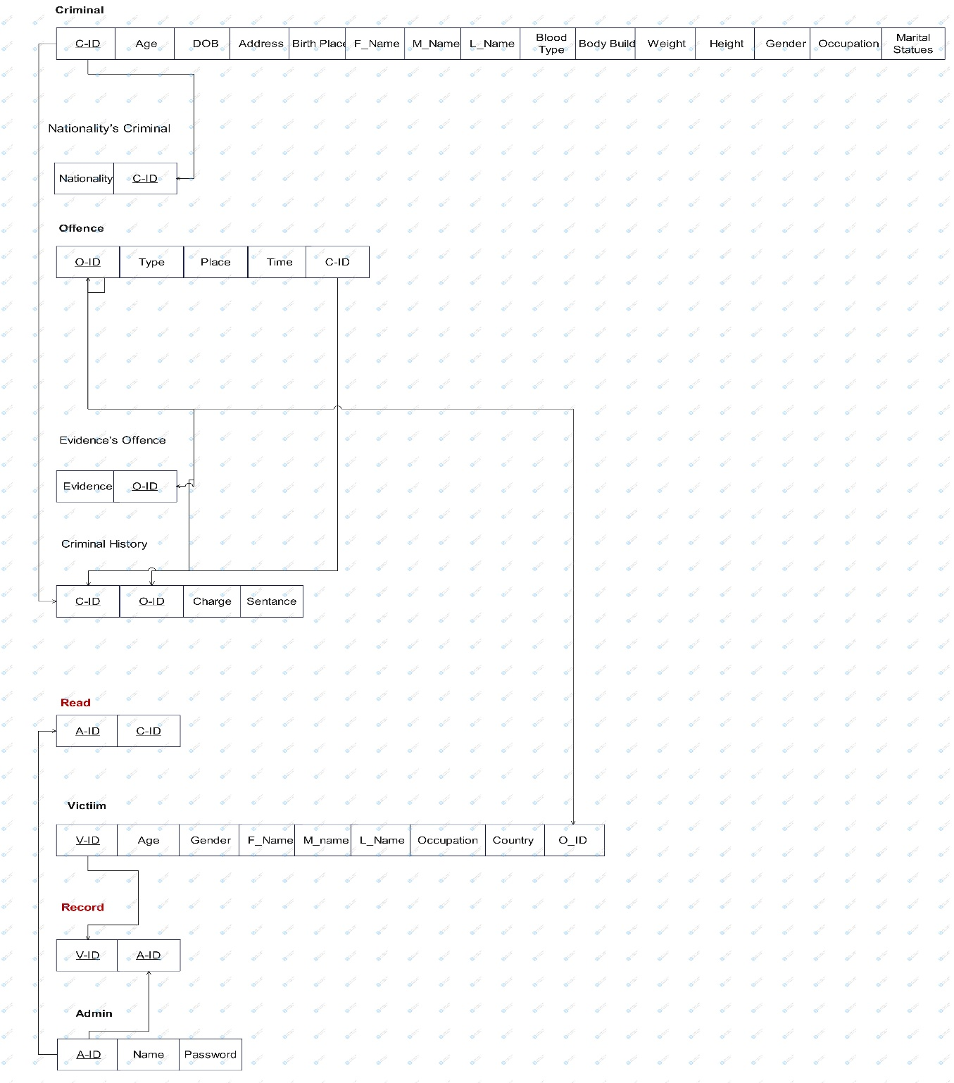

**-PROCESSING**

**1NF “Final Schema in Single or Simple Attribute”**

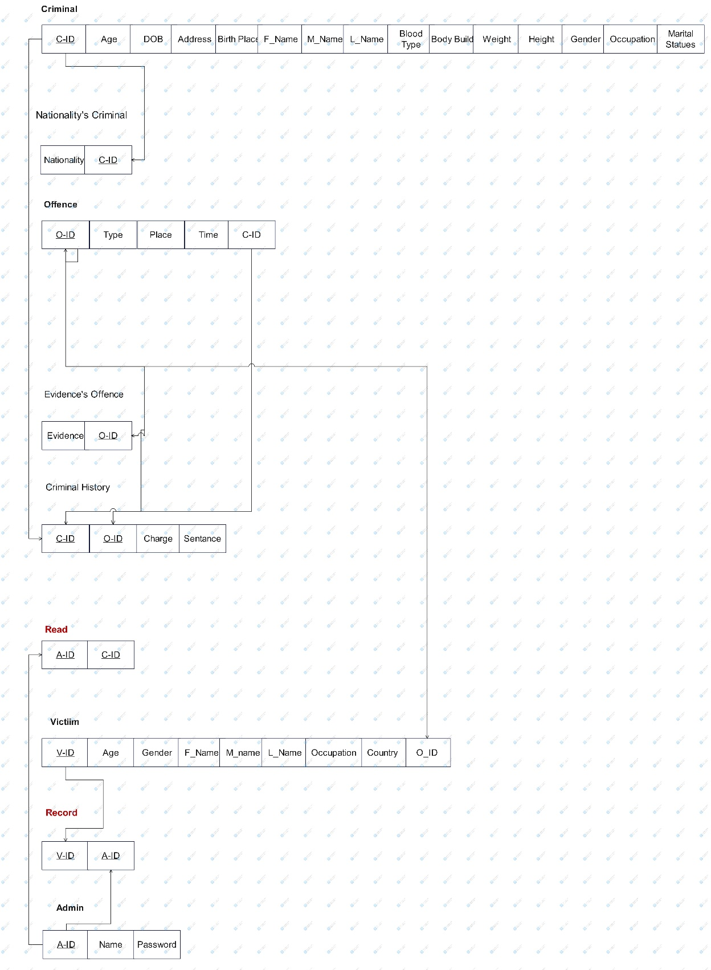

**2NF “No Partial Dependencies”**

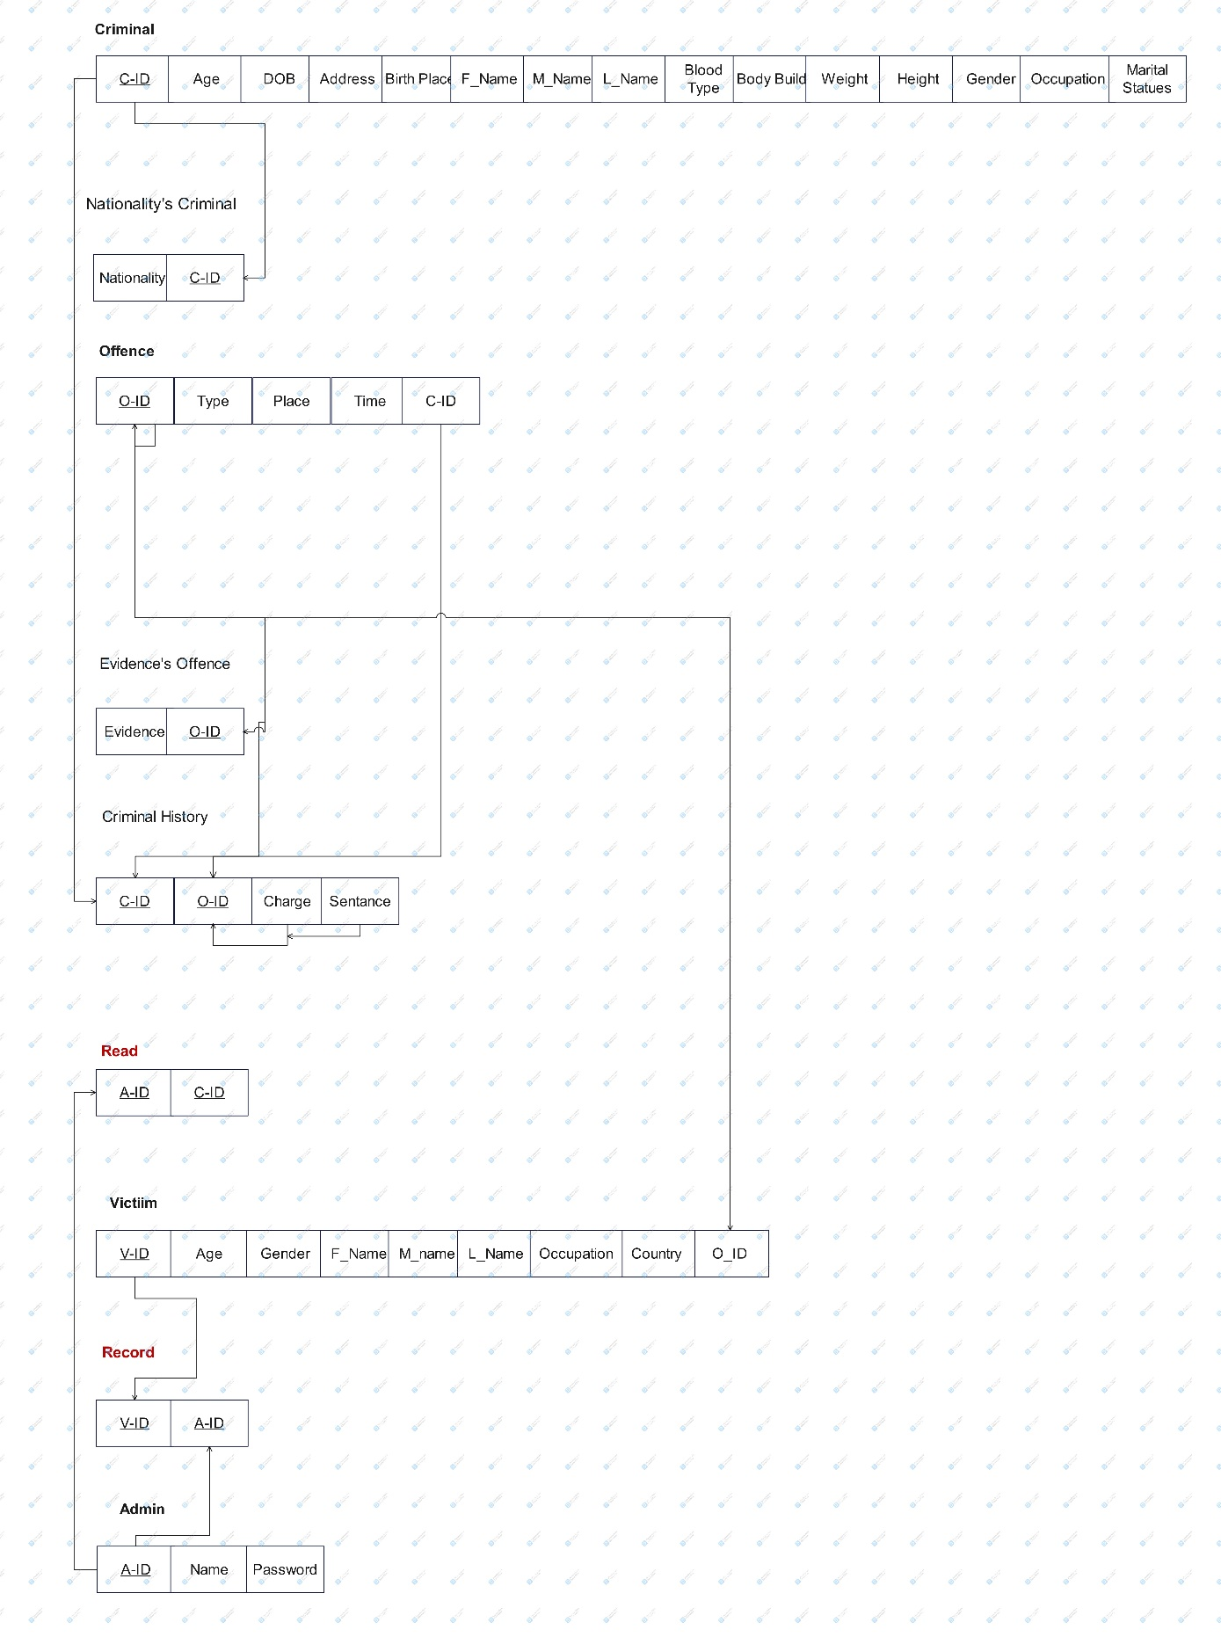

**3NF “No Transitive Dependencies”**

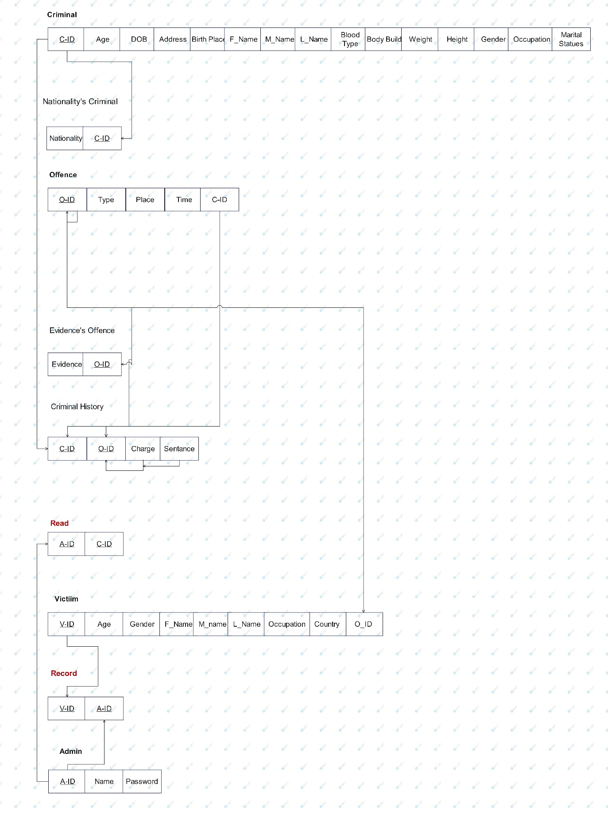

**- OUTPUT:**

